**Project Report**

**Topic - Profit Prediction using Regression Models**

Submitted By – Pratyush Karode

**Contents**

* Problem Statement
* Process Flow
* Exploratory Data Analysis
* Results
* Interpretation

**Problem Statement**

Create a supervised ML model to predict profit of a new company based on its Marketing, Administration and R&D Spending data.

**Process Flow**

Exploratory Data Analysis

Train Test Split

Regression Models

Evaluation of Models

Selection of Models

**Exploratory Data Analysis**

* The boxplot of the independent variables – Administration Spend, Marketing Spend and R&D Spend, shows that there are no outliers in the data.
* The distribution of Profits across the entire range of data is normal, indicating that there are no outliers present in the data. 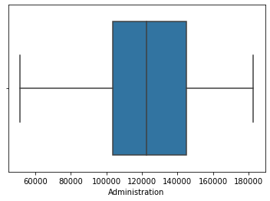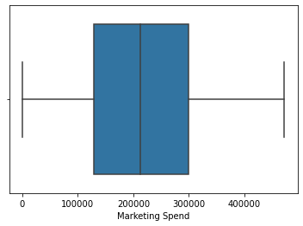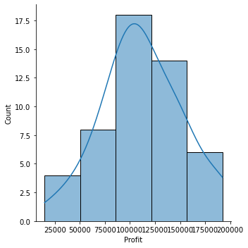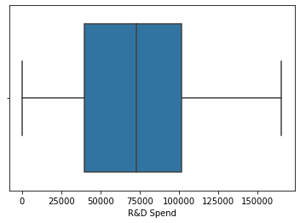
* The correlation matrix suggests that Profits have a strong correlation with R&D Spending.
* Marketing Spends also have a moderate level of correlation with Profits, while the correlation between Profits and Administration is very low.

**Results**

* Using only R&D Spend as the independent variable and it gave us very high R2 score of 0.93 and RMSE of 0.157.
* In Decision Tree Regression, utilizing all three independent variables, and it also gave us a high R2 score of 0.87 but RMSE was more than Linear Regression
* 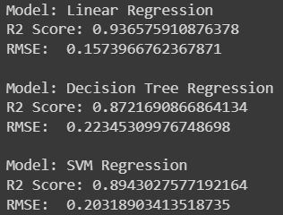SVM Regression, which also used all three independent variables, yielded an R2 score of 0.89 and RMSE of 0.203, which lies in between the R2 score and RMSE of the Linear Regression and Decision Tree Regression Models.

**Interpretation**

* Linear Regression is the best performing gives us the best results.
* There is some error in the predictions, but it can be reduced by training the model with a large set of data.
* This would decrease the overall error present in the current model.
* Currently, there is an issue of under fitting in the data.

**THANK YOU**